**CSC10003 – Object Oriented Programming**

**PROGRESS REPORT**

1. **Information**

**Group ID:** 11

**Group name:** Super Mario Bros OOP

**Members:**

|  |  |  |  |
| --- | --- | --- | --- |
| **ID** | **Student ID** | **Full name** | **CURRENT Tasks (%)** |
| **1** | 23127438 | Đặng Trường Nguyên | **25%** |
| **2** | 23127144 | Đinh Đại Vũ | **25%** |
| **3** | 23127489 | Nguyễn Ngọc Minh Thư | **25%** |
| **4** | 21126089 | Nguyễn Thể Phụng | **25%** |

1. **Percentage of completion**

**40% (Complete basic level 1 and main menu)**

1. **Github Link**

* https://github.com/trngnneeee/MarioGame

1. **Implemented features**
2. **Main menu**

* **Description:**
  + The main menu includes buttons: Play and Settings.
  + Currently, only the Play button is functional to start the game.
* **Screenshots**

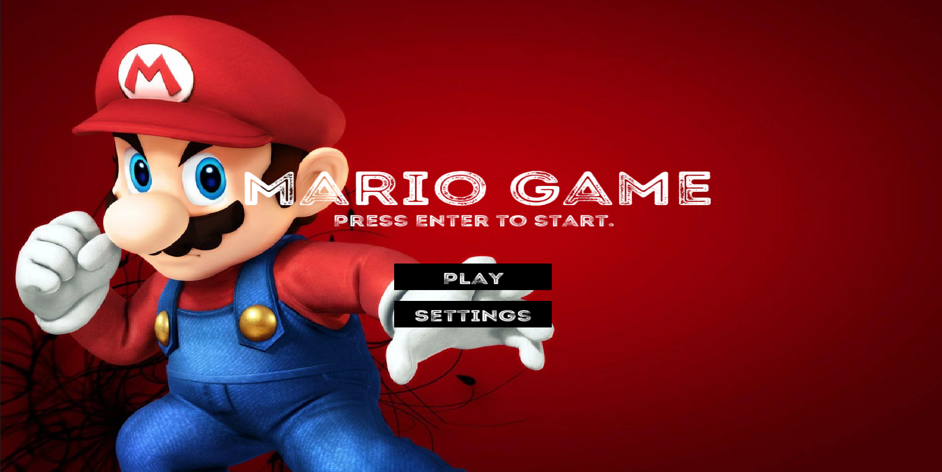

1. **UI for counting points, coin, Mario’s life, and game time**

* **Description:**
* **Points** that Mario get is updated and display into window and only reset when Mario if out of lifes.
* Each game, Mario have 3 **lifes**, when Mario is dead, the game is reset at the beginning of the game. If out of life, the game will be over and switch into Menu
* **Coin counter** have been added, but Coin haven’t been added to game
* **Game time** is set at default 300 seconds, if the time is running out, decrease the Mario lifes.
* **Screenshots:**

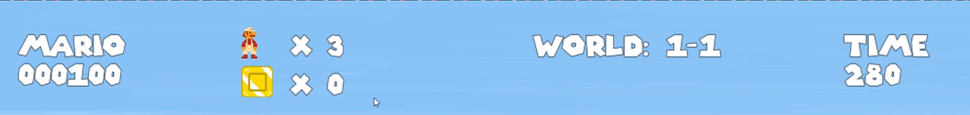

**Level 1 - Basic Movement System**

* **Description:**
  + Mario can **walk** and **jump** with basic animations.
  + Added **Animation** for walk and jump, splitted when Mario change movement direction.
  + Added sound effects for the **jump** action.
* **Screenshots:**

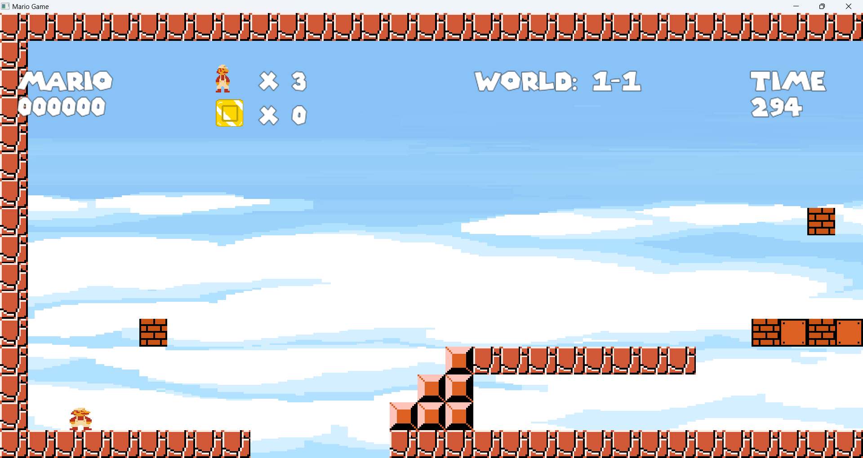

1. **Level 1 - Interaction System**

* **Description:**
  + Mario can break the brick to gain **50 points** per hit.
  + Blocks are designed and placed based on a predefined **map layout**, creating the game environment.
  + Mario can jump on **Goombas** to defeat them and gain **100 points**.
* **Screenshots**

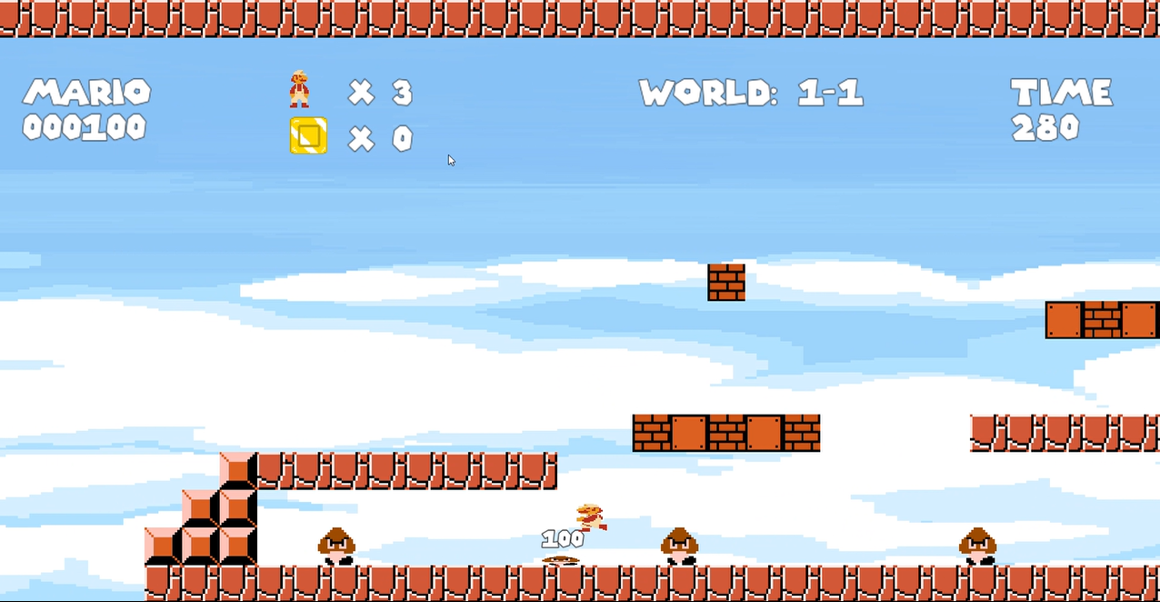

1. **Level 1 - Death System**

* **Description:**
  + Mario dies when:
    - Touching **Goombas**.
    - Falling into a pit.
  + Upon death, the game is reset to the beginning
  + If Mario is out of lifes, the game is over
  + Added sound effects if the game is over and turn back to the Menu
* **Screenshots**

1. **Level 1 - Enemy System**

* **Description:**
  + **Goombas** move back and forth autonomously within the level.
  + Added collision between each **Goombas**, the **Goombas** turn backward if touch each other
* **Screenshots**

1. **Specific techniques**

#### OOP Implementation

* **Encapsulation**:
  + Private member variables are used with getter and setter methods for controlled access.
* **Inheritance:** 
  + Class Goombas is inherited from class Enemy

**Design Patterns Applied**

* **State Pattern**:
  + Also used for managing game states: MainMenu, Playing, and GameOver.
* **Prototype Pattern**:
  + Used for creating repeated game objects like **Goombas**, **blocks**, and **coins** by cloning predefined prototypes.

#### Design Patterns Applied in the Future

1. **Singleton Pattern**:
   * Will be implemented in a **GameManager** class to manage game state globally, ensuring only one instance is active.
2. **Factory Pattern**:
   * Will be used to handle the creation of different types of enemies (e.g., **Goombas**, **Koopas**) through an **EnemyFactory** class.
3. **Observer Pattern**:
   * Planned for managing game events efficiently, such as:
     + **Collision events**: Detecting interactions between Mario and objects.
     + **Item collection events**: Updating the score and triggering sound effects when collecting items.
4. **Strategy Pattern**:
   * Will be used for varying behaviors of enemies or gameplay mechanics, such as different AI patterns for enemies or movement styles for Mario.
5. **Decorator Pattern**:
   * Will allow dynamic enhancement of objects, such as adding power-ups to Mario (FireMario, BigMario) or providing unique abilities to enemies (e.g., **faster movement** or **resistance to certain attacks**).
6. **Builder Pattern**:
   * Will simplify the creation of complex levels by using a **LevelBuilder** class to assemble maps, enemies, and items step-by-step.

#### Game Engine & Graphics

* Using **SFML** to render graphics.
* **Sprite Animation System**: Used for character animations.
* **Tile-based Map Loading**: Implemented to structure and dynamically load the game environment.

1. **References**

[Super Mario Bros. (1985) Full Walkthrough NES Gameplay [Nostalgia]](https://www.youtube.com/watch?v=rLl9XBg7wSs)

[New Super Mario Bros. DS HD - Full Game 100% Walkthrough](https://www.youtube.com/watch?v=fCsu_Eq0tbw)

<https://www.youtube.com/watch?v=aCq7P0e4cv0&list=PLlnvVTSJ0XwdnquTl8y5xvsY4aka_8h8H>

<https://en.wikipedia.org/wiki/Object-oriented_programming>

<https://gameprogrammingpatterns.com/>

<https://www.sfml-dev.org/documentation/2.6.1/>